Hexagonal Prismoid

Definition
# Source: AI Source: Provided by: [Data Path: Persons Table -> ID Column: 1, Name_En Column: Motasem Essam] -> From: [ChatGPT] on [7/25/2026]
A Hexagonal Prismoid is a three-dimensional polyhedron belonging to the Prismoid family, characterized by two hexagonal bases lying in parallel planes and connected by six quadrilateral lateral faces.
The two bases have six sides each but do not necessarily have the same size, shape, or orientation. The lateral faces are trapezoids or parallelograms.
It has 8 faces, 18 edges, and 12 vertices.

Geometric Structure
# Source: AI Source: Provided by: [Data Path: Persons Table -> ID Column: 1, Name_En Column: Motasem Essam] -> From: [ChatGPT] on [7/25/2026]
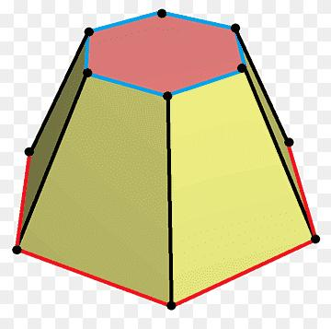
The solid consists of the following elements:
- Lower Hexagonal Base: A six-sided polygon forming the bottom of the solid.
- Upper Hexagonal Base: A hexagon parallel to the lower base.
- Lateral Faces: Six quadrilateral faces connecting corresponding edges of the two bases.
- Lateral Edges: Six edges connecting corresponding vertices of the bases.
- Altitude (Height): The perpendicular distance between the two base planes.
- Midsection: A hexagonal cross-section parallel to both bases, halfway between them.

Face Composition
# Source: AI Source: Provided by: [Data Path: Persons Table -> ID Column: 1, Name_En Column: Motasem Essam] -> From: [ChatGPT] on [7/25/2026]
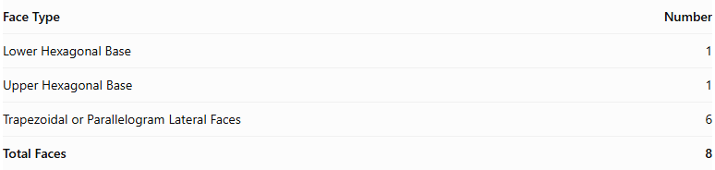
Face Type | Number
Lower Hexagonal Base | 1
Upper Hexagonal Base | 1
Trapezoidal or Parallelogram Lateral Faces | 6
Total Faces | 8
The six lateral faces may be trapezoids or parallelograms, depending on the relative positions and orientations of the bases.

Mathematical Properties
# Source: AI Source: Provided by: [Data Path: Persons Table -> ID Column: 1, Name_En Column: Motasem Essam] -> From: [ChatGPT] on [7/25/2026]
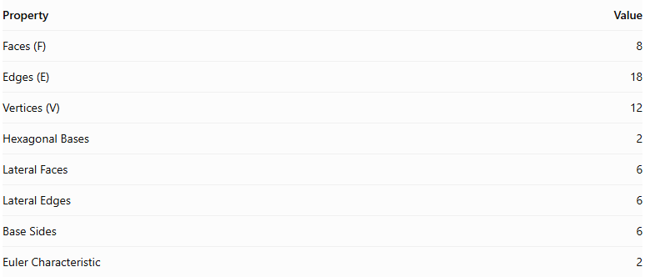
Property | Value
Faces (F) | 8
Edges (E) | 18
Vertices (V) | 12
Hexagonal Bases | 2
Lateral Faces | 6
Lateral Edges | 6
Base Sides | 6
Euler Characteristic | 2
Euler characteristic:
$$V-E+F=12-18+8=2$$
Volume Formula:
$$\boxed{V=\frac{h}{6}(A_{1}+4A_{m}+A_{2})}$$
Where:
- $V$ = Volume.
- $h$ = Perpendicular height.
- $A_{1}$ = Area of the lower hexagonal base.
- $A_{2}$ = Area of the upper hexagonal base.
- $A_{m}$ = Area of the hexagonal midsection.

Geometric Characteristics
# Source: AI Source: Provided by: [Data Path: Persons Table -> ID Column: 1, Name_En Column: Motasem Essam] -> From: [ChatGPT] on [7/25/2026]
- Hexagonal Bases: Both parallel bases have six sides and six vertices.
- Quadrilateral Lateral Faces: The solid has six trapezoidal or parallelogram lateral faces.
- Variable Base Geometry: The upper and lower hexagons may differ in dimensions and shape.
- Inclined Lateral Edges: The connecting edges may be inclined relative to the base planes.
- Convex Structure: In its conventional form, the solid has a convex closed surface.
- Variable Configurations: Its appearance depends on the shapes, dimensions, and relative positions of its two bases.

Types of Hexagonal Prismoids
# Source: AI Source: Provided by: [Data Path: Persons Table -> ID Column: 1, Name_En Column: Motasem Essam] -> From: [ChatGPT] on [7/25/2026]
Hexagonal prismoids can be further classified according to the shapes and relationships of their bases:
- Regular Hexagonal Prismoid
- Irregular Hexagonal Prismoid
- Similar-Bases Hexagonal Prismoid
- Non-Similar-Bases Hexagonal Prismoid

Constructing a Hexagonal Prismoid

Geometric Instruments
# Source: AI Source: Provided by: [Data Path: Persons Table -> ID Column: 1, Name_En Column: Motasem Essam] -> From: [ChatGPT] on [7/25/2026]
The following instruments can be used to construct a hexagonal prismoid using traditional geometric drawing methods:
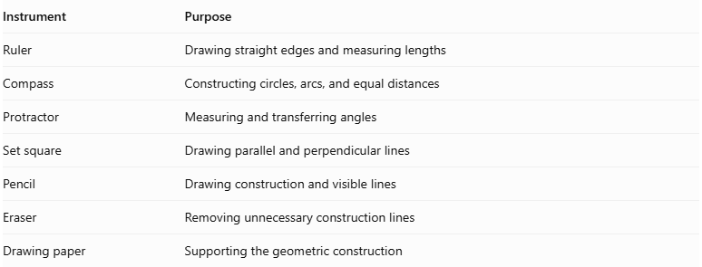
Instrument | Purpose
Ruler | Drawing straight edges and measuring lengths
Compass | Constructing circles, arcs, and equal distances
Protractor | Measuring and transferring angles
Set square | Drawing parallel and perpendicular lines
Pencil | Drawing construction and visible lines
Eraser | Removing unnecessary construction lines
Drawing paper | Supporting the geometric construction

Instrument-Based Construction Procedures

Method 1: Constructing from Two Parallel Hexagonal Bases
# Source: AI Source: Provided by: [Data Path: Persons Table -> ID Column: 1, Name_En Column: Motasem Essam] -> From: [ChatGPT] on [7/25/2026]
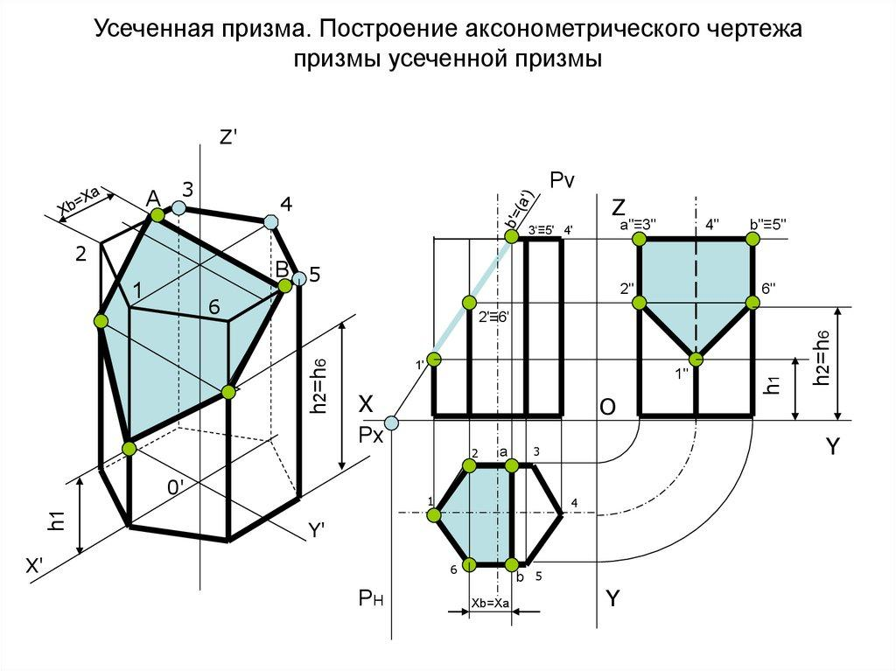
- Draw the lower hexagonal base $ABCDEF$ using a ruler, compass, and protractor.
- Establish the required perpendicular height above the lower base.
- Draw the upper hexagonal base $A'B'C'D'E'F'$ in a plane parallel to the lower base.
- Choose the dimensions and positions of the upper hexagon so that the corresponding connecting edges form planar lateral quadrilaterals.
- Connect $A$ to $A'$.
- Connect $B$ to $B'$.
- Connect $C$ to $C'$.
- Connect $D$ to $D'$.
- Connect $E$ to $E'$.
- Connect $F$ to $F'$.
- Join the corresponding base edges to complete the six lateral quadrilaterals.
- Erase unnecessary construction lines and distinguish visible edges from hidden edges.

Method 2: Constructing from a Hexagonal Base and Its Parallel Upper Section
# Source: AI Source: Provided by: [Data Path: Persons Table -> ID Column: 1, Name_En Column: Motasem Essam] -> From: [ChatGPT] on [7/25/2026]
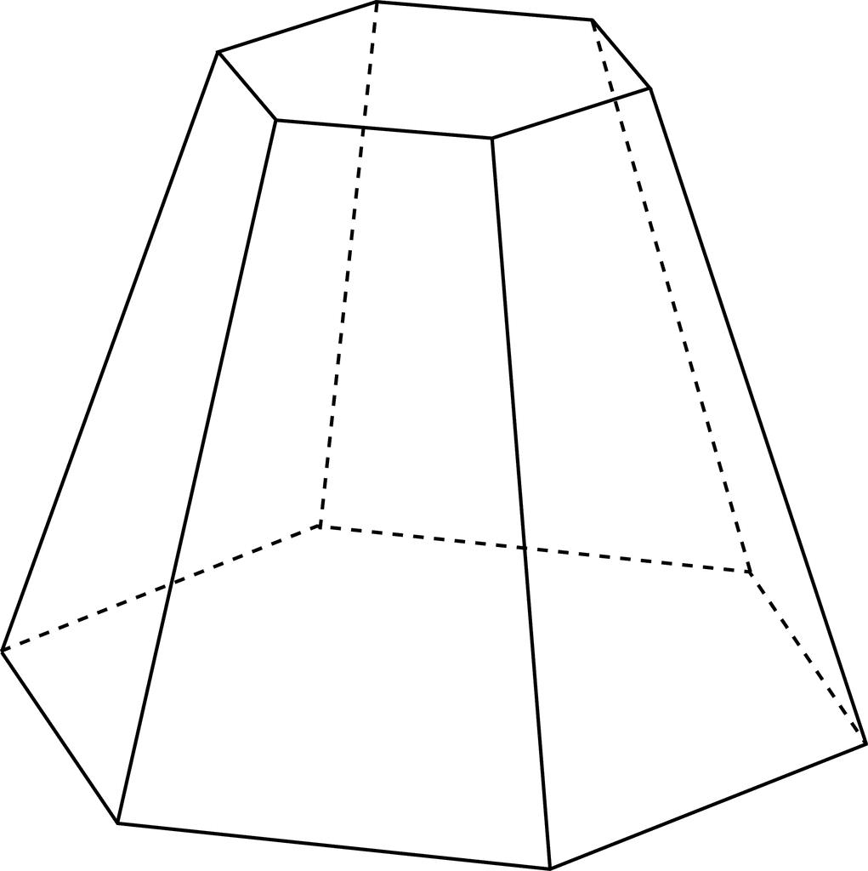
- Construct a hexagon $ABCDEF$ as the lower base.
- Draw a parallel upper construction plane at the required perpendicular height.
- Construct a second hexagon $A'B'C'D'E'F'$ on the upper plane.
- Determine the corresponding positions of the six upper vertices.
- Check that each pair of corresponding base edges and connecting lateral edges defines a planar quadrilateral.
- Connect the corresponding vertices.
- Complete all six lateral faces.
- Verify that the upper and lower bases are parallel.
- Finalize the drawing by removing auxiliary lines and marking visible and hidden edges.

Method 3: Constructing Through Parallel Cross-Sections
# Source: AI Source: Provided by: [Data Path: Persons Table -> ID Column: 1, Name_En Column: Motasem Essam] -> From: [ChatGPT] on [7/25/2026]
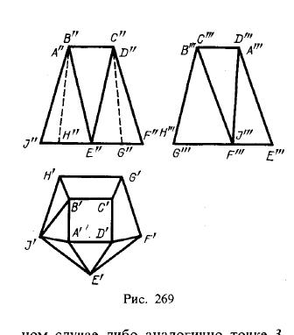
- Draw the lower hexagonal base $ABCDEF$.
- Establish the perpendicular height of the solid.
- Mark the halfway level between the two bases.
- Construct a middle hexagonal cross-section $A_{m}B_{m}C_{m}D_{m}E_{m}F_{m}$, parallel to the bases.
- Construct the upper hexagonal base $A'B'C'D'E'F'$.
- Connect the corresponding vertices of the lower, middle, and upper hexagons.
- Ensure that the resulting lateral faces are planar quadrilaterals.
- Complete the visible and hidden edges.
The middle cross-section is used when applying the prismoidal volume formula. Its area must be determined from the actual geometry rather than assumed to be the average of the two base areas.

Related Geometric Solids
# Source: AI Source: Provided by: [Data Path: Persons Table -> ID Column: 1, Name_En Column: Motasem Essam] -> From: [ChatGPT] on [7/25/2026]
- Hexagonal Prism – A special case with congruent parallel hexagonal bases.
- Hexagonal Pyramidal Frustum – A related solid with similar hexagonal bases.
- Hexagonal Prismatoid – The broader related geometric category.
- Hexagonal Bipyramid – A related hexagonal-faced polyhedron, but not a hexagonal prismoid under the narrower definition.

Main Classification
# Source: AI Source: Provided by: [Data Path: Persons Table -> ID Column: 1, Name_En Column: Motasem Essam] -> From: [ChatGPT] on [7/25/2026]
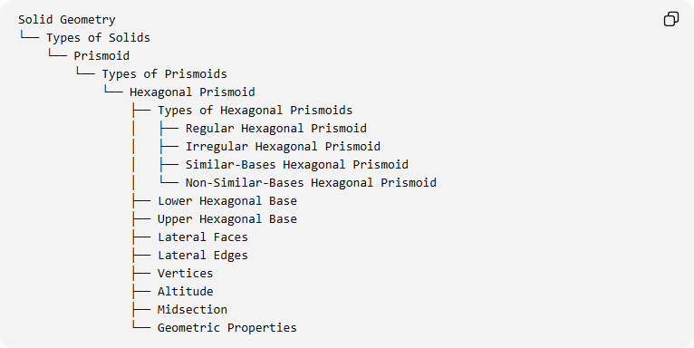
Solid Geometry
└── Types of Solids
└── Prismoid
└── Types of Prismoids
└── Hexagonal Prismoid
├── Types of Hexagonal Prismoids
│ ├── Regular Hexagonal Prismoid
│ ├── Irregular Hexagonal Prismoid
│ ├── Similar-Bases Hexagonal Prismoid
│ └── Non-Similar-Bases Hexagonal Prismoid
├── Lower Hexagonal Base
├── Upper Hexagonal Base
├── Lateral Faces
├── Lateral Edges
├── Vertices
├── Altitude
├── Midsection
└── Geometric Properties

Key Points
# Source: AI Source: Provided by: [Data Path: Persons Table -> ID Column: 1, Name_En Column: Motasem Essam] -> From: [ChatGPT] on [7/25/2026]
- A Hexagonal Prismoid has two parallel hexagonal bases.
- It contains six quadrilateral lateral faces.
- It has 8 faces, 18 edges, and 12 vertices.
- Its bases may differ in size, shape, and orientation.
- Its lateral faces are trapezoids or parallelograms.
- It can have regular or irregular hexagonal bases.
- Its volume is calculated using the prismoidal formula.

Conclusion
# Source: AI Source: Provided by: [Data Path: Persons Table -> ID Column: 1, Name_En Column: Motasem Essam] -> From: [ChatGPT] on [7/25/2026]
The Hexagonal Prismoid is the six-sided-base member of the Prismoid family. Its two parallel hexagonal bases and six quadrilateral lateral faces define its geometric structure, allowing different configurations according to the shapes and dimensions of its bases.

